|  |  |
| --- | --- |
| cetlogo ***CHEMICAL ENGINEERING TRANSACTIONS***  ***VOL. , 2025*** | A publication of  aidiclogo_grande |
| The Italian Association  of Chemical Engineering  Online at www.cetjournal.it |
| Guest Editors:  Copyright © 2025, AIDIC Servizi S.r.l. **ISBN** 979-12-81206-XX-X; **ISSN** 2283-9216 | |

Easy Digital Control of Refractance Window and Microwave Heating together for Sustainable Valorization of Orange Residuals

Ahmad Adeel Arshad a\*, Cristian Ramirez b, Francesca Colicignoc, Francesco Marrac

a Department of Science, Technology and Socity, University School for Advanced Studies IUSS Pavia, Palazzo del Broletto

Piazza della Vittoria, n.15, 27100 Pavia (PV), Italy

b Departamento de Ingeniería Química y Ambiental, Universidad Técnica Federico Santa María, Avenida España 1680, Valparaíso 2390123, Chile

c Dipartimento di Ingegneria Industriale, Università degli studi di Salerno, via Giovanni Paolo II 132, 84084 Fisciano (SA), Italy

\*Corresponding author: arshad.ahmad@iusspavia.it

This study explores the digital control of combined refractance window (RW) and microwave (MW) drying technologies to develop an effective and sustainable method for stabilizing orange pomace, a by-product of orange processing, and transforming it into a powder that maintains its functional properties. The drying system includes a microwave cavity, a glass container filled with water, Mylar film, and orange pomace spread on the film surface. Control of MW assisted heat transfer process is difficult because of a number of factors, such as high heating rates due to MW, issues in using thermal probes in the MW system given the possibility of interaction/disturbance with/of the electromagnetic field. The production of orange pomace powder was optimized by controlling the processing conditions (time, MW power) through a system that followed the time-evaluation of the temperature of the refractance window water and the orange pomace. The results indicated that, when optimal processing conditions were applied, the combined RW-MW system successfully lowered the water activity (Aw) of orange pomace below 0.3 within 40 minutes of drying time, thereby ensuring the powder's suitability for longer-term storage while maintaining its quality. This hybrid system's shorter drying time compared to other methods like freeze-drying, which generally require longer drying times. Furthermore, the RW-MW approach showed a notable decrease in energy usage when compared to conventional methods, thereby improving its sustainability. This innovative system presents a compelling approach to the valorization of orange pomace, often considered waste in the food industry. The system combines infrared radiation from RW and dielectric heating from the MW in a way that removes moisture effectively while protecting the bioactive compounds in the pomace, such as vitamins and antioxidants. The hybrid approach effectively reduces thermal degradation, which is a prevalent concern in traditional drying techniques. This study enhances the sustainable processing of agro-industrial by-products and the circular economy by converting waste into a valuable product that offers extended shelf life and potential future utilization.

* 1. Introduction

Orange global market size grows from $3.64 billion in 2024 to $3.87 billion in 2025 at a compound annual growth rate (CAGR) of 6.3% (The Business Research Company, 2025). In 2024, the gross production value of oranges in Italy was 559.84 million US dollars PPP (ReportLinker, 2024). Spain and Italy represent the leading EU citrus producers, followed by Greece, Portugal, and Cyprus. Additionally, Sicily and Calabria together produce about 86% of Italy's citrus crop (USDA, 2024) (U.S. Department of Agriculture, Foreign Agricultural Service, 2024).

A large portion of the yield is used in the production of orange juices, marmalades, candies, and jams, leading to generating a good deal of residue annually, including peels and segment membranes (Mahato et al., 2019). Orange residuals require appropriate and innovative handling (Li et al., 2023) because they are rich in organic matter, which is highly fermentable, have high water activity and have a short-term expiry date due to their nature, thus being unsuitable for disposal in the environment (Santagata et al., 2021). As a matter of fact, waste generated by oranges is an environmental, economic, and social problem, as it has a high biochemical oxygen demand for decomposition (Mahato et al., 2019); its management and disposal represent a cost; and, finally, its non-reuse contributes to the non-achievement of the 12 SDGs (Ferrara et al., 2023).

The most used stabilization process is based on the drying and the grinding of fresh residues immediately after processing, which can stabilise them and extend their shelf life, avoiding further waste and reducing environmental pollution. Food drying is a complex process that involves mass and heat transfer phenomena and structural changes coupled with the physical and chemical transformations of various compounds present in the food matrix (Morais et al., 2018). These transformations can significantly affect the nutritional quality, flavour, and texture of the food product. Therefore, understanding the underlying mechanisms of drying and grinding is crucial for optimising these processes and ensuring the production of high-quality stabilised food items.

In recent years, non-conventional methods like freeze drying, microwave drying and radio frequency drying are being applied to dry and stabilize the orange pomace (Elik et al., 2023). Freeze drying is more effective in preserving antioxidants but has some disadvantages, such as long drying times and high operational cost (Phuon et al., 2022). Microwave (MW) drying has been proved a fast-drying method by dielectric heating but at the same time this technology requires ad-hoc control design since it may lead to uneven heating distribution during the process, however MW assisted processes are recognized to contribute the sustainability goals (Marra, 2023).

Refractance Window (RW) drying, also known as hydro-conductive drying (Baeghbali et al., 2016), has gained attention in recent years as an effective method for dehydrating pulps and fruits while preserving food quality (Mahanti et al., 2021). It is a drying technique based on the use of hot water as a heating medium, which is in contact with a plastic film (mylar). The sample is placed on top of the plastic film and is primarily heated by conduction, which promotes faster water vaporization and allows the production of dried samples in a short drying time (Franco et al., 2019)

Therefore, RW drying technology emerges as a promising alternative, especially when coupled with other technologies such as microwaves. This combination could produce high-nutrition dried final product with a high bioactive compound content.

Previous studies underlined that when the biomass sample reaches the water activity (Aw) lower than 0.3, its temperature shows a rapid increase of increased time-derivative up to the temperature of the RW water (Núñez et al., 2023). So, this particular characteristic observed in the process can be used to alert a control system that the drying process has been completed, which can be a milestone in the RW-MW drying process upscaling.

This work aimed to study the drying of orange pomace using RW coupled with MW and digital control for precise drying time.

* 1. Material and methods
     1. Sample preparation

Fresh oranges (Citrus sinensis) were procured from a local market and maintained at ambient temperature until used. The oranges were cut into 4 pieces, and the juice was extracted by DICTROLUX's centrifuge juice extractor with 500W power and 1800 rpm and have the orange pomace.

* + 1. Drying with RW Coupled to Microwave (RW-MW)

The RW-MW drying system in Figure 1 used in this study is based on an RW system inside a microwave oven. For this, a glass container (21 x 15 x 6 cm3) filled with (300 ml) water and 50 grams of orange pomace on plastic mylar film (thickness of 0.1 mm) on the surface in contact with the water was placed inside the microwave chamber. The microwave cavity (Whirlpool Europe, Cassinetta, Italy) was modified with a power generator that controlled the microwave power, which was provided continuously. The microwave oven of 2450 MHz has variable power output settings ranging from 0 W to 900 W. Orange pomace was dried in the lab-scale RW-MW dryer system with an exhaust system to avoid moisture in the microwave chamber, as shown in Figure 1.

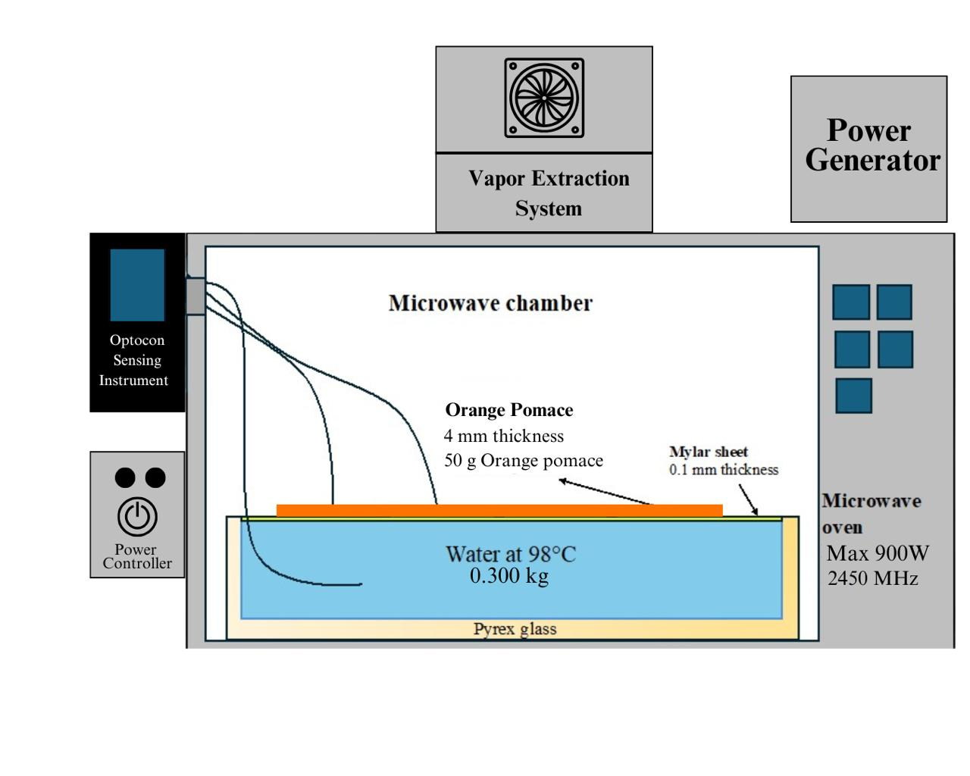

Figure 1: Refratance window - Microwave system

Refractance window water temperature and orange pomace temperature were monitored during RW-MW drying by Optocon (Weidmann, Germany) with fiber optics (TS2 type). RW-MW was operated at an output power level of 360 W in order to keep the water at 98°C during all the experiments. For this case, the microwave power density used was 8 W/g.

Drying time was controlled by a system following the time-evaluation of the water used in the refractive window

because the moisture content of 3 g water/100 g of sample (wet basis) to ensure Aw <0.3 the sample attained as the sample temperature increased from the water. Figure 2 shows the different transformation forms of oranges in the experiment. The drying experiment was performed in triplicate (n=3), and the results of the Aw were expressed as the mean ± standard deviation.

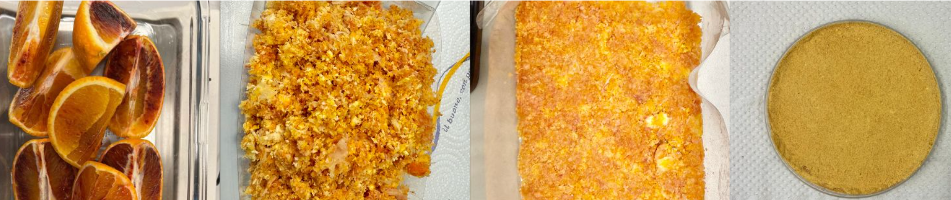

Figure 2: Orange transformation to orange pomace powder

* + 1. Determination of Water Activity

Water activity of all the samples was determined using the AquaLab Per Water Activity Meter (Decagon Devices, Pullman, WA, USA) with ± 0.01 Aw accuracy.

* 1. Results and Discussion

The RW-MW combined drying system demonstrated a highly efficient and rapid approach for reducing the Aw of orange pomace as shown in Figure 3 while maintaining its functional and nutritional properties.

Figure 3: Change in Water Activity over Time

Initially (t = 0 min), the orange pomace exhibited a high Aw of 0.984 ± 0.00252, reflecting the presence of abundant free water. The presence of this unbound moisture predisposes the substrate to microbial proliferation and biochemical reactions, highlighting the necessity for rapid and efficient drying techniques.

During the initial drying phase (t = 0–10 minutes), dielectric heating from microwave energy initiated the oscillation of polar water molecules within the pomace matrix. This phenomenon created localized thermal energy, enhancing moisture migration from the interior of the material toward the surface. Simultaneously, the Refractance Window layer facilitated heat transfer to promote surface evaporation. The cooling effect due to evaporative cooling prevented thermal degradation while supporting the removal of loosely bound surface water. This phase saw a reduction in Aw to 0.950 ± 0.00611, marking the initiation of capillary-driven moisture transport.

In the intermediate drying phase (t = 10–20 minutes), the system exhibited a significant decline in Aw, reaching 0.628 ± 0.01735, attributed to Fickian diffusion mechanisms. The generation of internal vapor pressure gradients by microwave energy accelerated moisture transport within the material, while infrared radiation through the RW layer further supported surface evaporation. The effective water diffusivity (D\_eff) during this phase was enhanced due to structural modifications such as pore formation, which facilitated moisture migration, while ensuring the retention of structural integrity as in Figure 4.

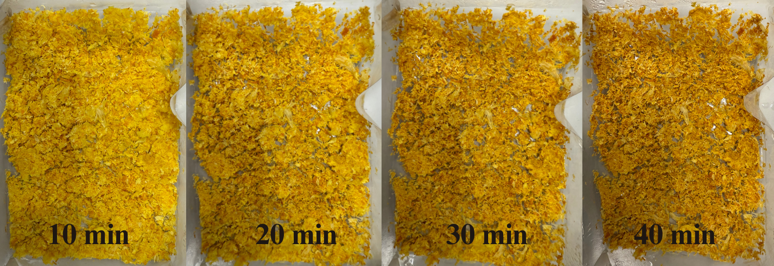

Figure 4: Different stages of orange pomace while drying

At t = 30 minutes, the Aw decreased to 0.291 ± 0.00862, indicating the removal of tightly bound water. This phase involved the dominance of monolayer water interactions, where molecular mobility is increasingly restricted. The system maintained a balance between heat transfer and moisture removal, ensuring minimal damage to the material's biochemical attributes. Notably, pore formation in this phase enhanced moisture diffusion, while capillary collapse began to influence structural changes as bound water content diminished, as in Figure 2.

In the final drying phase (t = 40 minutes), Aw stabilized at 0.159 ± 0.02914, below the microbial stability threshold (Aw < 0.4). During this stage, heat transfer mechanisms shifted predominantly to conduction due to reduced moisture content. The structural adjustments, such as capillary collapse, further limited moisture pathways, yet the system preserved the overall structural integrity of the pomace. The precision of the RW-MW system ensured temperature control, mitigating the risks of excessive thermal degradation and preserving the product's bioactive compounds.

* 1. Conclusion

The growing global orange market leads to significant orange by product, presenting both environmental and economic challenges. The digitally controlled RW-MW hybrid system synergizes conductive, dielectric, and infrared mechanisms to sustainably valorize orange pomace. By automating phase-specific adjustments, it achieves rapid drying within 40 minutes, ensuring energy efficiency and high nutrient retention. This system positions itself as a scalable solution for the upcycling of agro-industrial waste, offering a sustainable approach to orange pomace management. Future work will focus on integrating IoT-enabled sensors for real-time tracking of nutrient retention during the drying process, further enhancing its efficiency and effectiveness.

Nomenclature

Aw – Water Activity

MW – Microwave

RW – Refratance Window

RW Water – Water used in Refratance Window

Acknowledgments

The authors would like to express their sincere gratitude to all those who contributed to the success of this study. This article and associated research were conducted as part of the Italian inter-university PhD program in sustainable development and climate change (https://www.phd-sdc.it/). Special thanks to University of Salerno for providing the necessary resources and facilities. Cristian Ramírez acknowledge the financial support of Fondecyt project 1230506.

References

Baeghbali, V., Niakousari, M., & Farahnaky, A. (2016). Refractance Window drying of pomegranate juice: Quality retention and energy efficiency. *LWT, 66*, 34–40. https://doi.org/10.1016/j.lwt.2015.10.017

Elik, A., Armağan, H. S., Göğüş, F., Oboturova, N., Nagdalian, A., Smaoui, S., & Shariati, M. A. (2023). Impact of radio frequency-assisted hot air drying on drying kinetics behaviors and quality features of orange peel. *Biomass Conversion and Biorefinery, 13*(16), 15173–15183. https://doi.org/10.1007/s13399-023-04336-0

Ferrara, A., Candia, V., & Ferranti, P. (2023). Technological processes to produce novel ingredients from agri-food sources: Functional compounds from citrus wastes. In *Sustainable Food Science—A Comprehensive Approach* (pp. 380–391). Elsevier. https://doi.org/10.1016/B978-0-12-823960-5.00042-1

Franco, S., Jaques, A., Pinto, M., Fardella, M., Valencia, P., Núñez, H., Ramírez, C., & Simpson, R. (2019). Dehydration of salmon (Atlantic salmon), beef, and apple (Granny Smith) using Refractance Window: Effect on diffusion behavior, texture, and color changes. *Innovative Food Science and Emerging Technologies, 52*, 8–16. https://doi.org/10.1016/j.ifset.2018.12.001

Li, C., McClements, D. J., Dai, T., Jiang, D., Deng, L., Liu, C., & Chen, J. (2023). Improving food sustainability by converting orange peel waste products into hydrogels using stirred media milling. *Journal of Food Engineering, 366*, Article 111813. https://doi.org/10.1016/j.jfoodeng.2023.111813

Mahanti, N. K., Chakraborty, S. K., Sudhakar, A., Verma, D. K., Shankar, S., Thakur, M., Singh, S., Tripathy, S., Gupta, A. K., & Srivastav, P. P. (2021). Refractance Window™-Drying vs. other drying methods and effect of different process parameters on quality of foods: A comprehensive review of trends and technological developments. *Future Foods, 3*(February), 100024. https://doi.org/10.1016/j.fufo.2021.100024

Mahato, N., Sinha, M., Sharma, K., Koteswararao, R., & Cho, M. H. (2019). Modern extraction and purification techniques for obtaining high purity food-grade bioactive compounds and value-added co-products from citrus wastes. *Foods, 8*(11), 523. https://doi.org/10.3390/foods8110523

Marra, F. (2023). Combining computer-aided food engineering and electro-heating applications as a contribution to food processing sustainability. *Frontiers in Sustainability, 4*, 1170467.

Morais, R. M. S. C., Morais, A. M. M. B., Dammak, I., Bonilla, J., Sobral, P. J. A., Laguerre, J. C., Afonso, M. J., & Ramalhosa, E. C. D. (2018). Functional dehydrated foods for health preservation. *Journal of Food Quality, 2018*. Hindawi Limited. https://doi.org/10.1155/2018/1739636

Núñez, H. J. (2023). Effect of CO₂ laser microperforation pretreatment on the dehydration of apple slices during refractive window drying. *Foods, 12*(11), 2187. https://doi.org/10.3390/foods12112187

Phuon, V., Ramos, I. N., Brandão, T. R. S., & Silva, C. L. M. (2022). Assessment of the impact of drying processes on orange peel quality characteristics. *Journal of Food Process Engineering, 45*(7), e13794.

ReportLinker. (2024). ReportLinker. ReportLinker. Retrieved from https://www.reportlinker.com/dataset/c934233079e72ccb766456f036e1430abc30c523

Santagata, R., Ripa, M., Genovese, A., & Ulgiati, S. (2021). Food waste recovery pathways: Challenges and opportunities for an emerging bio-based circular economy. A systematic review and an assessment. Journal of Cleaner Production, 286, Article 125490. https://doi.org/10.1016/j.jclepro.2020.125490

The Business Research Company. (2025). *Orange global market report*. The Business Research Company. Retrieved from https://www.thebusinessresearchcompany.com/report/orange-global-market-report

U.S. Department of Agriculture, Foreign Agricultural Service. (2024). *Citrus annual*. USDA. Retrieved from https://apps.fas.usda.gov/newgainapi/api/Report/DownloadReportByFileName